Regionally Aligned Priorities in Delivering Skills (“RAPIDS”) 8
Request for Proposals
Submission due September 9, 2026
- Program Purpose
To support the Regionally Aligned Priorities in Developing Skills (“RAPIDS”) program, and as appropriated in Section 207.01 of Senate Bill 450 of the 136th General Assembly, the Ohio Department of Higher Education (“ODHE”) will make strategic regional investments in equipment and facilities to develop and support postsecondary institutions’ workforce development projects that enhance the economic growth of students and businesses. The investments will directly impact the ability of the state of Ohio to retain and expand existing businesses, attract new enterprises, and further entrepreneurship by addressing regional talent and workforce needs. These regional investments (in a total of seven regions – map available here and attached hereto as Appendix A) will address regionally identified industry-specific occupation and skill requirements. Additionally, the program aims to support collaborative projects among higher education institutions to strengthen education and training opportunities that maximize workforce development efforts in defined areas of the state. Capital funds appropriated for this purpose by the General Assembly shall be distributed by the Chancellor of Higher Education to Ohio regions or subsets of regions. Regions or subsets of regions may be defined by the state's economic development strategy.
Successful proposals will:
- Describe/document how the institution is prioritizing RAPIDS investments to support technician-aligned pathways that will help grow Ohio’s economy. The programs (CIPS) aligned to the pathways are linked and listed in Appendix B.
- Use state-level data to support industries employing technicians and other targeted regional industries with in-demand occupations. Areas of investment with the opportunity to impact Ohio’s economy include advanced manufacturing (including semiconductor technology and auto & advanced mobility), broadband and 5G, cybersecurity, and building and construction trades.
- Provide sufficient documents demonstrating business/industry support for the proposed program(s).
- Develop a plan to address gaps in workforce preparation related to the selected industries and in-demand occupations.
- Identify equipment that must be purchased to support the plan.
- Clearly explain how equipment will enable a variety of students to acquire career skills through credit and/or non-credit courses and programs.
Additionally, in reviewing applications and making awards, priority shall be given to proposals that demonstrate:
- Collaboration among and between state institutions of higher education, as defined in section 3345.011 of the Revised Code, Ohio Technical Centers, and other entities as determined to be appropriate by the Chancellor;
- Evidence of meaningful business support and engagement;
- Identification of targeted occupations and industries supported by data, sources for which may include the Governor's Office of Workforce Transformation, OhioMeansJobs, labor market information from the Department of Job and Family Services, and lists of in-demand occupations; and
- Sustainability beyond the grant period with the opportunity to provide continued value and impact to the region.
In submitting proposals for consideration under the program, a state institution of higher education, as defined in section 3345.011 of the Revised Code, shall be the lead applicant and preference shall be given to proposals:
- in which equipment and technology acquired by capital funds awarded under the program are owned by a state institution of higher education. If equipment, technology, or facilities acquired by capital funds awarded under the program will be owned by a separate governmental or nonprofit entity, the state institution of higher education shall enter into a joint use agreement with the entity, which shall be approved by the Chancellor.
- that request funds for specific, well-defined equipment purchases.
- Eligible Applicants
Proposals will be developed by a regional collaborative. Regions are required to collaborate on an executive narrative and base it around regional impact and in-demand industries. Individual proposals from each fiscal agent (public community college or university) will include the regional executive summary with the specific projects for the fiscal agent and proposed sub-awardee partners such as OTCs, regional campuses, and independent colleges and universities. Proposals must include local economic development partner, and a minimum of one business support letter submitted by each participating institution, pertaining to the relevant project(s). Each fiscal agent will submit its own proposal consisting of a full proposal narrative as described below and budget workbook.
- Anticipated Awards
Six regional awards of $1,218,750 will be made and Northeast Ohio will receive $2,687,500, equally divided among three areas ($895,832.50) within the region. All eligible fiscal agents and potential partners in each region can be found in Appendix A. If a region does not submit a RAPIDS proposal within the timeframe that receives approval, the funds may be reallocated to other regions.
- Eligible Expenses and Project Term
Grant funds are to be expended for the purposes set forth in Senate Bill 450 of the 136th General Assembly and must be used for eligible capital expenses; see Section 207.01 Workforce Based Training and Equipment – Taxable (Senate Bill 450) for details of how funds may be used. The source of the fund is Higher Education Bonds, Fund 7024. Careful consideration will be given to the entire proposed budget, including other sources of funds.
A project may purchase equipment that can be placed at an Ohio Technical Center, university regional campus, or independent college or university for education and training purposes. Access to the equipment by the participating institutions and students would be provided through an MOU or a lease agreement with an identified fiscal agent. These funds may not be used to make permanent improvements at the OTC.
All grant expenditures must be properly procured following Ohio Revised Code and Administrative rules. When planning the implementation of RAPIDS 8 project(s), ODHE reminds each institution that Ohio’s procurement policies encourage a competitive selection process that avoids sole sourcing purchases and encourages buying from Ohio vendors when possible. ODHE urges institutions to follow Ohio’s recommended practices when purchasing RAPIDS equipment, which demonstrates fiscal stewardship and due diligence.
It is recommended that institutions purchase large equipment, at a minimum cost of $25,000 per item.
Investments in curriculum development, faculty development, marketing, and other related costs are not eligible expenses under this RFP.
It is anticipated that the work covered by the RFP will begin in December 2026 and continue through June 30, 2028, with a final expense report due December 31, 2028, to the Ohio Department of Higher Education. A desk and/or site audit will occur prior to the final closeout of the grant. Additional data on project outcomes may be solicited until June 2031.
- Award Recommendations
The Chancellor, after considering the recommendations of internal and external reviewers, shall make the final determination about which proposals, if any, shall be recommended for funding to the Controlling Board. ODHE shall determine the amount of recommended funding for each applicant and the nature of any conditions on funding. All recommendations of ODHE are subject to Controlling Board approval. If requested, fiscal agents must attend the Controlling Board meeting when proposals are considered for funding. All fiscal agents on behalf of consortia will be notified of the outcome of their proposal after the Chancellor makes funding decisions.
- Proposal Review Process and Timeline
Proposals can be submitted beginning July 24, 2026, and are due no later than September 9, 2026. They must be submitted in the following manner:
- One electronic, searchable PDF file with the components listed in Section VII and one Excel file using the Budget Workbook template from the RAPIDS webpage submitted to the ODHE RFP Portal for RAPIDS 8.
- Applicants are responsible for timely submissions of proposals. Proposals become property of ODHE and are subject to public record laws of the state. Proposals containing all the required elements will receive careful consideration but cannot be guaranteed funding. Accepted proposals will be evaluated by a review team that will be composed of representatives from several state agencies and other stakeholders, following the rubric approved by ODHE. The Chancellor will make final decisions based upon the quality of the proposal in addressing the RFP criteria and its required elements.
- The schedule below may be revised by ODHE due to circumstances and any changes will be communicated to the applicants via e-mail and posted on the RAPIDS web page, https://highered.ohio.gov/initiatives/workforce-development/rapids.
Request for Proposals Released July 24, 2026
RFP Webinar July 28, 2026
Proposals Submission Window July 24, 2026 – September 9, 2026
Proposal Review begins September 10, 2026
Anticipated Notification of Awarded Proposals November 2026
*ODHE anticipates awarding the allocated funds in November 2026. Funds will be transferred to institutions after Controlling Board approval and execution of a grant agreement with ODHE. Institutions will request a release of funds from the Controlling Board after completing appropriate procurement procedures. Unallocated dollars as of October 8, 2026, may be reallocated to other workforce development and equipment investments.
Please note that the funds covered by the RFP are authorized by Senate Bill 450 of the 136th General Assembly, which is the capital bill for the biennium in effect from July 1, 2026, to June 30, 2028. Therefore, continued access to funds that are not released to the institution by the Controlling Board and expended or encumbered prior to June 30, 2028, will be subject to the biennial capital reappropriations process. While it is anticipated that unreleased funds will be reappropriated by the General Assembly without objection, this action cannot be guaranteed and should therefore be taken into consideration by institutions when developing and executing project timelines.
ODHE will provide an opportunity for potential applicants to seek assistance regarding their application through a webinar on July 28, 2026, registration for which is available here along with other technical assistance. Applicant questions are to be submitted in writing via email to RAPIDS@highered.ohio.gov. Responses to questions will be posted online to provide the information to interested parties.
Additional information regarding the program is available by contacting John Magill, Associate Vice Chancellor, Economic Advancement, at 614.752.9530.
- Proposal Requirements
Formatting Guidelines:
Proposals must be submitted in Arial font, 10 points or larger; there is an exception for tables and images. Please see below for page allocations and directions for each section of the proposal. Please clearly label each of the following sections within the proposal submission.
Each eligible fiscal agent in a region will submit its own proposal narrative PDF and budget workbook Excel, with the regional budget represented on the Regional Budget tab of the Excel workbook. Institutions within a region are encouraged to collaborate on their cover letters and executive summaries to align their workforce needs and strategies.
Proposal Narrative PDF Components:
  - Cover Letter (one page): Title of project; identify the primary contact plus the fiscal agent, capital purchasing contact, and legal authorizing contact by name, title, address, phone number, and email address.
  - Executive Summary: Include: 1) rationale for the targeted regional industries and in-demand occupations; 2) a synopsis of the plan to address workforce needs for these targeted industries; and 3) a description of how the equipment investment will strengthen education and training opportunities that maximize workforce development efforts as described in Senate Bill 450 of the 136th General Assembly, Section 207.01.
  - Project Narrative: The narrative for each fiscal agent and any subawardee’s projects with the eight components as listed below:
- Project Narratives are required to address the following criteria, in order:
        - Project Design: Description of the plan to address a regional workforce need through strategic investment in equipment and facilities that will be used in postsecondary credit and/or noncredit educational programs, to strengthen education and training opportunities that maximize workforce development efforts, as described in SB 450. This description should, at minimum, list the location(s) of the project (with map) and describe how the equipment will be accessed by students in the region, including those at OTCs, community colleges, and universities, and incumbent workers, if applicable.
        - If the equipment is mobile, describe the service area (with map) and possible locations (2-3) to be served.
- Occupations: Identify and list the in-demand occupations that will be targeted through this workforce program.
              - Using the Ohio LMI Occupational Employment Projections tool found at https://ohiolmi.com/Home/DS_Results_OCCPROJ, please identify by Code and Title the relevant occupations for each project. These must be listed at a minimum in the Budget Workbook, where requested, and can be supplemented in the proposal with other data sources such as OhioMeansJobs, Executive Pulse, and/or Lightcast.
              - Regional businesses: Identify the local, regional businesses and industries that will benefit from an increase in the number of individuals educated or trained for these in-demand jobs.
        - Letters of support from local, regional businesses must be original, distinct, and written by the business. Each letter must reference the equipment investment and related workforce development education and training, and must reference specific, in-demand jobs/occupations.
- Industries: Provide the Jobs Ohio Industry North American Industrial Code System (NAICS) Code for each targeted industry, and list businesses participating in the project(s). At a minimum, these codes must be listed in the Budget Workbook and may be supplemented in the proposal with narrative or data from OhioMeansJobs, Executive Pulse, and/or Lightcast.
        - Discuss how this project will support regional economic development strategies and draw on the advice of industry, economic development professionals, workforce investment boards (WIBs), and other regional stakeholders.
        - Describe how equipment will enable students and incumbent workers to acquire career skills through credit and/or non-credit courses and programs leading to opportunities in the identified industries and occupations.
        - Describe how input was received input from industry partners, and how they will be involved in the implementation of the project.
        - Explain how/why workforce collaboration is critical to program success and document the collaboration expected throughout the project. Note: Attachments, including business letters of support, should provide evidence of a commitment to collaboration.
        - Describe with two or three examples how the equipment investment will improve workforce education and skills for the regional industries.
- Students: Describe the student population(s) on which there will be a focus and the corresponding recruitment, retention, and job placement strategies for each population.
        - Types of students can include, but are not limited to, traditional students, adult learners (including adults seeking a high school credential), veterans, incumbent workers, and College Credit Plus high school students. Provide an estimate of the expected number of students impacted by the project annually.
- Institutional support: Include a formal commitment to project success. Indicate any financial or in-kind contributions, including existing equipment and facilities, articulation agreements, and other activities that will contribute to success.
    - List and describe the credit or non-credit courses that will be provided to help meet the identified industry and job needs, and their relationship to targeted in-demand occupations.
    - The list will include institution, department, CIP, and/or course name, if non-credit offering.
      - If applicable, identify CIP codes specifically that align with the list in Appendix B.
      - Describe the types of curriculum changes and faculty training needed to integrate the equipment into courses; provide examples of how the equipment will be integrated into a program.
      - Identify any facility investments and other equipment needed to support the courses.
    - Note: Institutional or other partner letters/agreements should provide evidence of commitment to projects and any pertinent leveraged funding.
- Budget Narrative: The budget narrative will provide background related to the costs of equipment and deployment at the institutional level. Requests must be supported with third-party cost estimates for all the equipment investment. These are only estimates to show reasonable cost, and if the proposal is funded, the applying institution(s) will need to follow State of Ohio proper procurement policies and procedures. The budget narrative should include:
- Itemized costs.
- The underlying assumption for each cost (i.e., base cost of item, number of items, etc.).
- Third-party cost estimates are required for all equipment purchases to ensure reasonable project proposals. The estimate must be specific to the proposed equipment type. Third-party cost estimates are to provide documentation to support the proposed project costs. The estimates do not require an institution to select a particular vendor, and every purchase must follow Ohio’s competitive procurement processes. Cost estimates should include clear prices per-unit and total estimated prices for the requested amount of equipment.
- Any matching funds that will be leveraged, clearly labeled (matching funds are not required for the RAPIDS program). Matching funds may pay for curriculum development, building improvements, supplies, professional development, and other items not covered by RAPIDS state dollars.
- Each institution seeking a grant agreement must describe the competitive procurement processes and evaluation it will complete prior to purchasing eligible capital equipment that comply with State of Ohio proper procurement policies and procedures.
- A description by each institution of how the project(s) will be sustained beyond the grant period and continue to provide education and training benefits.
- Project Plan: This section should provide a clear description and timeline for activities to be undertaken and will be included as a separate attachment in the grant agreement.
- Outline the roles and responsibilities of key staff members, along with pertinent biographies and experience.
- Provide a GANNT chart with proposed activities, dependencies, and estimated completion milestone for each activity.
- A separate project plan must be included for any subawardees.

- Project Evaluation: Explain how project success will be measured. The evaluation plan should include both formative and summative measurements. Project evaluation must include a system to measure, i.e., academic achievement and regional economic impact, which may include productivity gains and cost savings.
ODHE will collect academic and economic data related to the project for three years after the end of the agreement. These data will include and are not limited to the specific metrics listed and described in the proposal’s evaluation plan.
  - Describe the evaluation design. Clearly explain how academic achievement and economic impact will be defined and measured.
  - Describe the ongoing evaluation process, including collecting data, analyzing data, responding to data (i.e., developing improvement plans), and reporting data to ODHE.
  - Provide a timeline for the evaluation process, including formative and summative evaluations complementing the project GANTT chart.
  - Identify the individuals who will lead the evaluation process.
  - Budget Workbook Excel Components: The budget workbook submitted in Excel must have the following components completed:
      - Regional Budget Tab: This tab should be the same for every fiscal agent submitting a proposal in a region. Every participating institution should be represented, with all subawardees listed under the fiscal agent with whom they agree to collaborate.
      - Fiscal Agent Tab: As proposals will be submitted separately by each eligible fiscal agent, this tab should represent only the detailed budget of the fiscal agent and any subawardees that will specifically partner with that fiscal agent. Please ensure that the attached budget from the institutions represented by the fiscal agent matches the quoted price per the estimate for each piece of equipment.
  - Additional Attachments: Proof of commitment from all parties responsible for the implementation of this project is required. Include unique, original letters of support from each business that communicates its dedication to this RAPIDS program. Materials on the specific location of each item of equipment are required. Additional visuals or informational brochures are allowable.
- Reporting Requirements
The Ohio Department of Higher Education will monitor each project for which an award is granted to ensure that there is fiscal accountability and operating progress, and that the desired outcomes are achieved. Regular reports (semi-annually) will be required from all awardees through a standard reporting template or system. ODHE may request additional documentation up to three years after project completion to review the impact of the investments.
- Legal Notices
The applicant understands that if its application is accepted by the State, the applicant shall enter into an agreement with the State governing the use of the awarded funds. The applicant agrees to comply with all applicable federal, state, and local laws and regulations in the conduct of the work hereunder.

The State reserves the right to fund any application in full or in part, to request additional information to assist in the review process, to require new applications from interested parties, to reject any or all applications responding to this announcement, or to reissue the announcement if it is determined that it is in the best interest of the State of Ohio. Issuing this announcement does not bind the State to making any awards. The State reserves the right to adjust the dates for this announcement for whatever reasons are deemed appropriate. The State reserves the right to waive any non-substantive infractions made by an applicant, and reserves the right to request changes and corrections to a proposal.
All costs incurred in preparation of an application shall be borne by the applicant. Application preparation costs are not recoverable under an award. The State of Ohio shall not contribute in any way to recovering the costs of application preparation.
The funding decisions are final. Applicants will be notified of the outcome of their application(s) at the conclusion of the review process.
The applicant understands that the information provided herein is intended solely to assist the applicant in submittal preparation. To the best of the State’s knowledge, the information provided is accurate. However, the State does not warrant such accuracy, and any errors or omissions subsequently determined will not be construed as a basis for invalidating this solicitation. Interested parties bear the sole responsibility of obtaining the necessary information to submit a qualifying application. The State retains the right to modify or withdraw this solicitation at any time. By submitting an application, applicants expressly agree to these terms.
- Trade Secrets
All lead applicants are strongly discouraged from including in a proposal any information that the lead applicant considers to be a “trade secret,” as that term is defined in Section 1333.61(D) of the Ohio Revised Code. All information submitted in response to this RFP is public information unless a statutory exception exists that exempts it from public release under the Ohio Public Records Act in Section 149.43 of the Ohio Revised Code.
If any information in the proposal is to be treated as a trade secret, the proposal must:
  - Identify each and every occurrence of the information within the proposal with an asterisk before and after each line containing trade secret information, and underline the trade secret information itself;
  - Identify that the proposal contains trade secret information in the cover letter; and
  - Include a summary page immediately after the cover letter that lists each page in the proposal that includes trade secret information and the number of occurrences of trade secret information on that page.
  - To determine what qualifies as trade secret information, refer to the definition of “trade secret” in the Ohio Revised Code at 1333.61(D), which is reproduced below for reference:
(D) “Trade Secret” means information, including the whole or any portion or phase of any scientific or technical information, design, process, procedure, formula, pattern, compilation, program, device, method, technique or improvement, or any business information or plans, financial information, or listing of names, addresses, or telephone numbers that satisfies both of the following:
(1) It derives independent economic value, actual or potential, from not being generally known to, and not being readily ascertainable by proper means by, other persons who can obtain economic value from its disclosure or use.
(2) It is the subject of efforts that are reasonable under the circumstances to maintain its secrecy.
  - The Ohio Department of Higher Education requires non-disclosure agreements from all non-ODHE persons who may have access to proposals containing trade secret information, including evaluators.
  - If the applicant claims that a record is not subject to disclosure under the Ohio Public Records law based on trade secret, it will bear costs of defending this claim.
- Capital Funds
Use of the funds shall comply with the requirements set forth in Senate Bill 450, Ohio Department of Higher Education and state institutions of higher education as passed by the 136th Ohio General Assembly and signed by Governor DeWine. The funds for this program are from Fund 7024 (Taxable). Any private use should be noted through standard Controlling Board processes. Additional information regarding private use and reporting can be found on the RAPIDS webpage.
Capital funds awarded through this RFP may not be used for operating expenses of the project.
SECTION 207.41.
For all appropriations in this act from the Higher Education Improvement Fund (Fund 7034) or the Higher Education Improvement Taxable Fund (Fund 7024) that require local funds to be contributed by any state-supported or state-assisted institution of higher education, the Department of Higher Education shall not recommend that any funds be released until the recipient institution demonstrates to the Department of Higher Education and the Office of Budget and Management that the local funds contribution requirement has been secured or satisfied. The local funds shall be in addition to the appropriations in this act.
SECTION 207.42.
None of the capital appropriations in this act for state-supported or state-assisted institutions of higher education shall be expended until the particular appropriation has been recommended for release by the Department of Higher Education and released by the Director of Budget and Management or the Controlling Board. Either the institution concerned or the Department of Higher Education with the concurrence of the institution concerned may initiate the request to the Director of Budget and Management or the Controlling Board for the release of the particular appropriation.
SECTION 207.43.
    - No capital appropriations in this act made from the Higher Education Improvement Fund (Fund 7034) or the Higher Education Improvement Taxable Fund (Fund 7024) shall be released for planning or for improvement, renovation, construction, or acquisition of capital facilities if the institution of higher education or the state does not own the real property on which the capital facilities are or will be located. This restriction does not apply in any of the following circumstances:
        - The institution has a long-term (at least 20 years) lease of, or other interest (such as an easement) in, the real property.
        - The Department of Higher Education certifies to the Controlling Board that undue delay will occur if planning does not proceed while the property or property interest acquisition process continues. In this case, funds may be released upon approval of the Controlling Board to pay for planning through the development of schematic drawings only.
        - In the case of an appropriation for capital facilities that, because of their unique nature or location, will be owned or will be part of facilities owned by a separate nonprofit organization or public body and will be made available to the institution of higher education for its use or benefit, the nonprofit organization or public body either owns or has a long-term (at least 20 years) lease of the real property or other capital facility to be improved, renovated, constructed, or acquired and has entered into a joint or cooperative use agreement with the institution of higher education that meets the requirements of division (C) of this section.
    - Any appropriations that require cooperation between a technical college and a branch campus of a university may be released by the Controlling Board upon recommendation by the Department of Higher Education that the facilities proposed by the institutions are:
      - The result of a joint planning effort by the university and the technical college, satisfactory to the Department of Higher Education;
      - Facilities that will meet the needs of the region in terms of technical and general education, taking into consideration the totality of facilities that will be available after the completion of the projects;
      - Planned to permit maximum joint use by the university and technical college of the totality of facilities that will be available upon their completion; and
      - To be located on or adjacent to the branch campus of the university.
    - The Department of Higher Education shall adopt and maintain rules regarding the release of moneys from all the appropriations for capital facilities for all state-supported or state-assisted institutions of higher education. In the case of capital facilities referred to in division (A)(3) of this section, the joint or cooperative use agreements shall include, as a minimum, provisions that:
      - Specify the extent and nature of that joint or cooperative use, extending for not fewer than 20 years, with the value of such use or benefit or right to use to be, as is determined by the parties and approved by the Department of Higher Education, reasonably related to the amount of the appropriations;
      - Provide for pro rata reimbursement to the state should the arrangement for joint or cooperative use be terminated prior to the expiration of its full term;
      - Provide that procedures to be followed during the capital improvement process will comply with appropriate applicable state statutes and rules, including the provisions of this act; and
      - Provide for payment or reimbursement to the institution of its administrative costs incurred as a result of the facilities project, not to exceed 1.5 percent of the appropriated amount.
    - Upon the recommendation of the Department of Higher Education, the Controlling Board may approve the transfer of appropriations for projects requiring cooperation between institutions from one institution to another institution with the approval of both institutions.
    - Notwithstanding Section 127.14 of the Revised Code, the Controlling Board, upon the recommendation of the Department of Higher Education, may transfer amounts appropriated to the Department of Higher Education to accounts of state-supported or state-assisted institutions created for that same purpose.
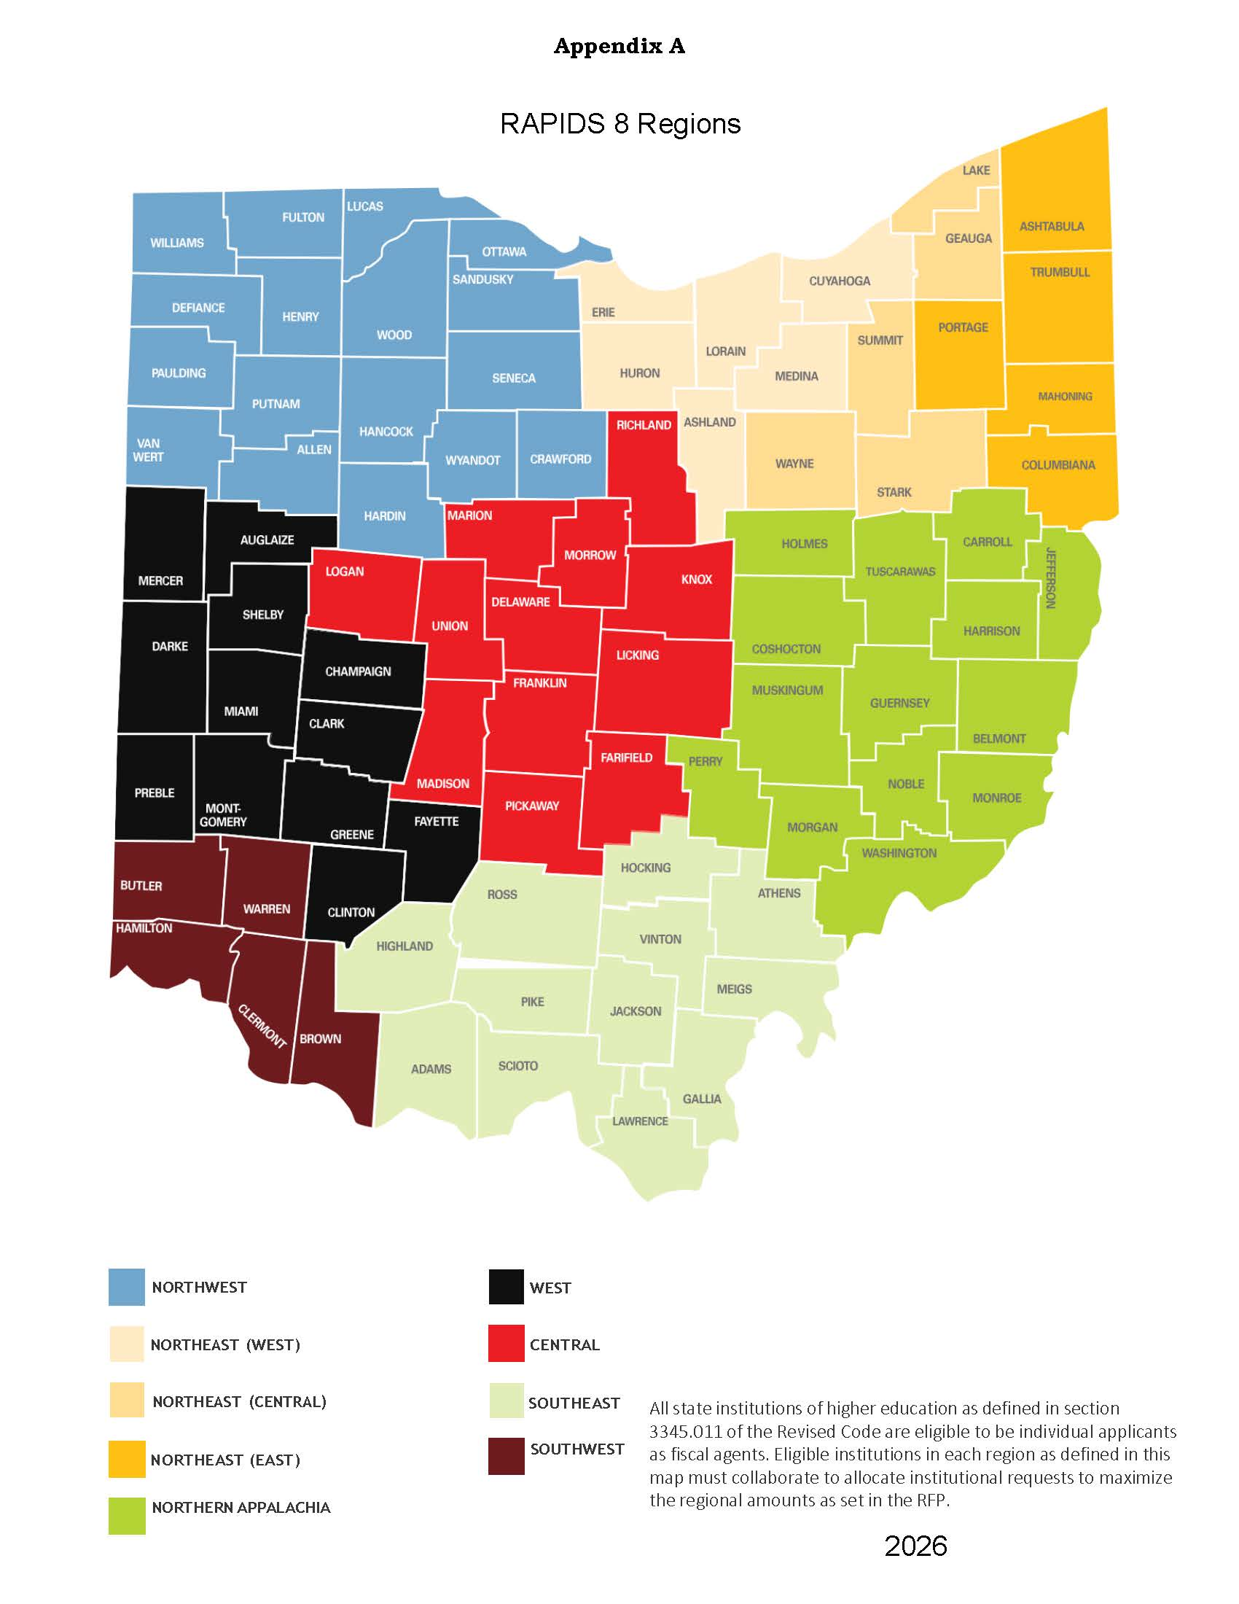

- Central
Eligible fiscal agents: Central Ohio Technical College, Columbus State Community College, Marion Technical College, North Central State College, and The Ohio State University
Potential career center partners: Columbus City Schools, C-TEC, Delaware Area Career Center, Eastland-Fairfield Career Center, Knox County Career Center, Madison Career Center, Pioneer Career Center, Tolles Career Center, and Tri-Rivers Career Center
- Northeast Ohio/East
Eligible fiscal agents: Youngstown State University and Kent State University
Potential career center partners: Ashtabula County Technical and Career Center, Choffin Career & Technical Center, Columbiana County JVSD, Mahoning County Career & Tech Center JVSD, Maplewood Career Center JVSD, and Medina County JVSD
- Northeast Ohio/Central
Eligible fiscal agents: University of Akron, Northeast Ohio Medical University, Lakeland Community College, and Stark State College
Potential career center partners: Auburn JVSD, Buckeye JVSD, Canton City SD, Portage Lakes JVSD, Wayne County JVSD, and Willoughby-Eastlake City SD
- Northeast Ohio/West
Eligible fiscal agents: Cleveland State University, Cuyahoga Community College, and Lorain County Community College
Potential career center partners: Ashland County-West Holmes JVSD, Cuyahoga Valley Career Center JVSD, EHOVE Career Center, Lorain County JVSD, Polaris JVSD, and Sandusky City SD
- Northern Appalachia
Eligible fiscal agents: Belmont College, Washington State College of Ohio, and Zane State College
Potential career center partners: Mid-East Career & Technology Centers and Washington County Career Center
- Northwest
Eligible fiscal agents: Bowling Green State University, Northwest State Community College, Owens Community College, University of Toledo, Rhodes State College, and Terra State Community College
Potential career center partners: Apollo Career Center, Four County JVSD, Penta Career Center JVSD, Toledo City SD, Vanguard-Sentinel JVSD, and Vantage Career Center
- Southeast
Eligible fiscal agents: Hocking College, Ohio University, Rio Grande Community College, Shawnee State University, and Southern State Community College
Potential career center partners: Buckeye Hills Career Center, Collins Career Technical Center, Pickaway - Ross Career Technical Center, Pike County Career Technology Center, Scioto County Career Technical Center, and Tri-County Career Center
- Southwest
Eligible fiscal agents: Cincinnati State Technical & Community College, Miami University, and University of Cincinnati
Potential career center partners: Brown & Clermont Adult CC, Butler Technology & Career Development Schools JVSD, Great Oaks Career Campuses, and Warren County JVSD
- West
Eligible fiscal agents: Central State University, Wright State University, Clark State College, Edison State Community College, and Sinclair Community College
Potential career center partners: Greene County Career Center, Miami Valley Career Technology Center, and Upper Valley Career Center

Updated 6.26.26

Appendix B
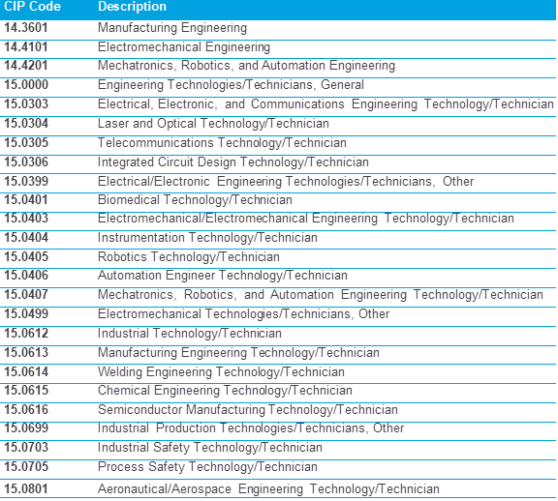

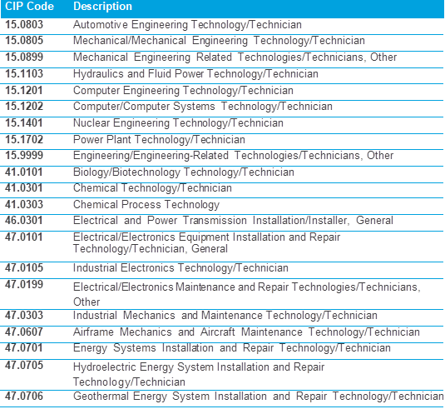

Appendix C
FAQs re: Eligible Participants and Regional Alignment
Is there a requirement for IHE's to include OTC's and interested independent colleges and universities that operate within their region?
- Yes, OTCs and independents have been valuable partners and have executed many successful RAPIDS projects to the state’s workforce training efforts. Collaboration is a crucial part of the enabling legislation and intent of the RAPIDS program.
Are OTCs only able to participate as subawardees?
- Yes, OTCs and independents must have a selected fiscal agent (state IHE) in their region. The RAPIDS program receives funding from Higher Education Bond proceeds that can only be awarded to community colleges and public universities.
Independent colleges and universities are not listed in Appendix A. Are they still eligible to participate?
- Yes. OTCs (listed in Appendix A) and independent colleges and universities (not specifically listed) are both eligible as subawardees, and must partner in their region with an eligible state IHE (listed in Appendix A) as a fiscal agent. IHEs must support the collaboration and participation of all eligible entities.
- To see a list of independent colleges in Ohio, please see ODHE’s “Ohio’s Campuses” webpage at https://highered.ohio.gov/about/ohioscampuses/independent‐campuses, to identify partners in your region.
Can we collaborate with a local career center for equipment?
- Yes, Ohio Technical Centers are eligible subawardees, partnering in their region with an eligible state institution of higher education (listed in Appendix A). Collaboration and sharing of resources are highly encouraged!
Independent colleges and universities could partner with a state‐funded IHE. But could we not partner with an OTC like Super RAPIDS?
- Correct, an Ohio Technical Center is not an eligible fiscal agent in the RAPIDS program. OTCs must also partner with a public state institution of higher education. The RAPIDS program receives funding from Higher Education Bond proceeds that can only be awarded to community colleges and public universities.
How can a regional campus participate in RAPIDS 8?
- University regional branch campuses located in the same region as the main campus are expected to coordinate regional collaboration with the main campus. Regional campuses located in a different region may participate in the region they are located, communicating with their main campus, and collaborating with the institutions in the region. The award agreements will be issued to the main institution with the amounts identified for any regional campus. If there are any regional campuses in the same region as the main campus, we request that they submit proposals together with separate sections. The main campus will be aware of all regional campus activities pertaining to RAPIDS, and institutions are expected to coordinate internally across campuses and with their regions for successful communications.
Can all the eligible subawardees in a region participate?
- All interested participants must be included in the regional discussions for allocating funding.

Office of Budget and Management (OBM) policy requires that leases and lease Agreement Covering equipment owned by non-profit entities needs to be 20 years.

